1. Descriptive statistics of the data sets

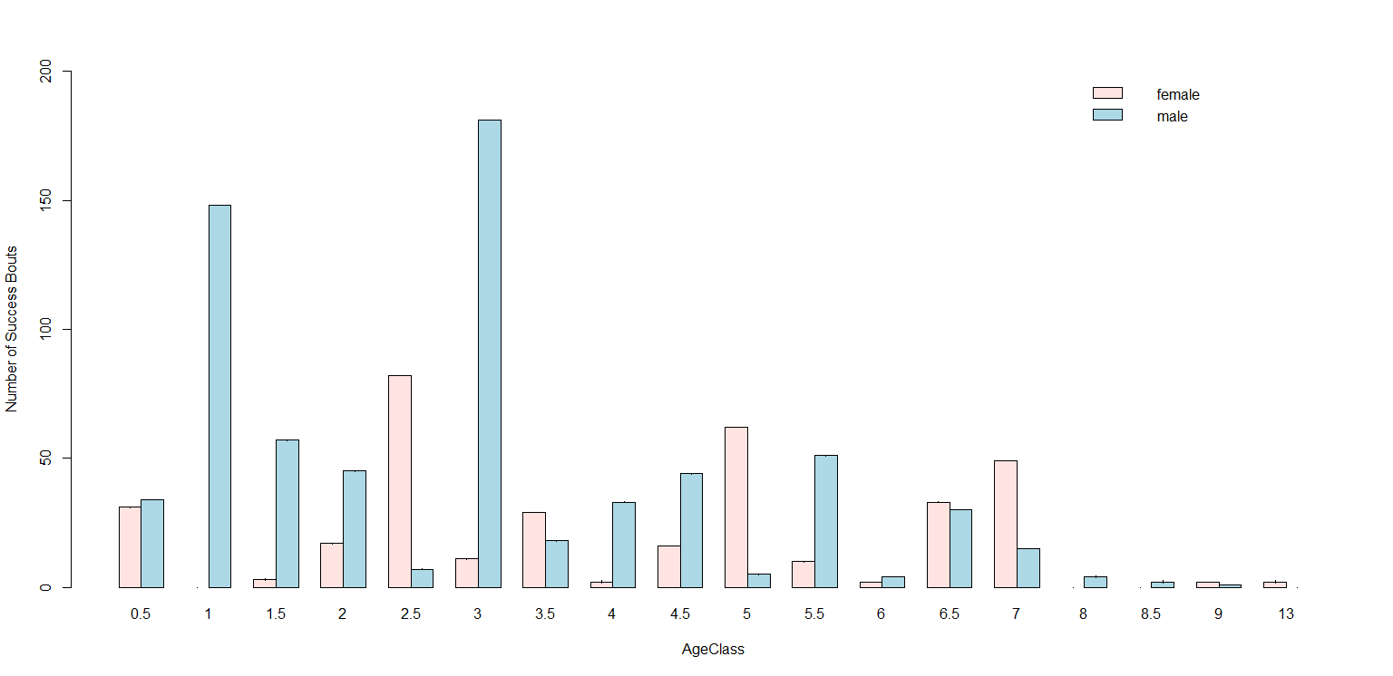

**Table: Count of occurrences of the food items: 108 distinct food items (I= food item; C= count of the occurrence).**

|  |  |  |  |  |  |  |  |  |  |  |  |
| --- | --- | --- | --- | --- | --- | --- | --- | --- | --- | --- | --- |
| I | C | I | C | I | C | I | C | I | C | I | C |
| AAB_FR | 3 | APLS_FR | 1 | BSG_BK | 8 | GESBENG | 7 | MDGH_FR | 11 | RP_VE | 3 |
| ADDG_LV | 3 | APPLE_FR | 1 | BSG_FR | 41 | GLMB_LV | 4 | MDGK_FR | 4 | RP7_LV | 1 |
| ADDG_VE | 1 | APSB_LV | 1 | CARROT_ROOT | 6 | INSECT_IN | 1 | MLK_FL | 1 | RSKB_BK | 1 |
| AJK_VE | 3 | APSB_VE | 1 | CATCH | 2 | JAIR_FL | 1 | MLK_FR | 83 | RSKB_FR | 4 |
| AKAR_LV | 28 | ASDK_VE | 11 | CELERY_ROOT_PIECE_ROOT | 7 | KELINCI_VE | 1 | MNGH_FR | 18 | RSKB_LV | 3 |
| AKAR_NA | 7 | ASK_FR | 1 | CELERY_ROOT_ROOT | 8 | KKCNG_FR | 2 | OAK_LEAVES_LV | 12 | RSKP_FR | 19 |
| AKAR_VE | 7 | ASK_LV | 14 | CELERY_STEM_VE | 6 | KOHLRABI_ROOT | 3 | PAPRIKA_FR | 12 | RSKP_LV | 12 |
| AKKT_LV | 1 | ASK_VE | 24 | CEREAL_OAT | 1 | KULBT_FR | 11 | PKSKW_VE | 2 | RSKU_FR | 17 |
| APD_LV | 3 | AT_VE | 3 | CHINESE_CABBAGE_VE | 2 | KULJM_FR | 1 | PRD_FR | 8 | RTKS_LV | 4 |
| APKS_LV | 4 | ATB_VE | 6 | CMG_FR | 91 | LEEK_VE | 4 | PWN_FR | 57 | RTKS_VE | 32 |
| APKS_VE | 3 | ATPS_VE | 1 | COOKED_CARROT_PAPERWRAP_ROOT | 2 | LIME_LEAVES_LV | 1 | RAYAP_IN | 150 | RTN_VE | 7 |
| APKSB_LV | 3 | BEETROOT_ROOT | 6 | DEADWOOD | 8 | MADU_IN | 4 | RGH_FR | 4 | RTP_FR | 1 |
| APKSB_VE | 2 | BNGPR_FL | 1 | FENNEL_ROOT | 3 | MADU_KERINGAT_IN | 8 | RNGS_BK | 7 | RTPB_LV | 1 |
| APLO_LV | 2 | BNGPR_FR | 2 | FISTFISHING | 2 | MDGB_FR | 10 | RNGS_FR | 15 | SALAD_VE | 18 |
| APLO_VE | 2 | BROCCOLI_VE | 1 | FLOUR_OATMEAL_GRAIN_OAT | 11 | MDGBR_FR | 3 | RP_LV | 11 | SEMUT_IN | 27 |
| SPG_FR | 43 | TMPGRW_FR | 9 | TREEHOLE | 1 | ULAT_IN | 8 | UNK_FR | 8 | UNK_VE | 9 |
| STICK | 2 | TOOLUSE | 3 | TWIG | 4 | UNK | 98 | UNK_IN | 42 | WILLOW_LEAVES_LV | 26 |
| TLS_BERDURI_LV | 1 | TPSBT_FR | 16 | UBR_FR | 20 | UNK_BK | 1 | UNK_LV | 31 | ZUCCHINI_PIECE_FR | 2 |

2. Effects on Begging Success **(based on the wild data set only)**

2.1. Model suggested by Caroline

**Model structure**: full_wild<- glmer(Success ~ ExactAge + Sex + ProcessingSteps_Complexity + PopFreq_Rarity +(1|Beggar)+(1|Mother) + (1|AgeClass) ,data =wild, family = binomial, control = glmerControl(optimizer = "bobyqa"),nAGQ = 1)

*I'm not trying to get inferences from the random intercepts, the singular fit issue can be therefore ignored (Roger Mundry, 2020).*

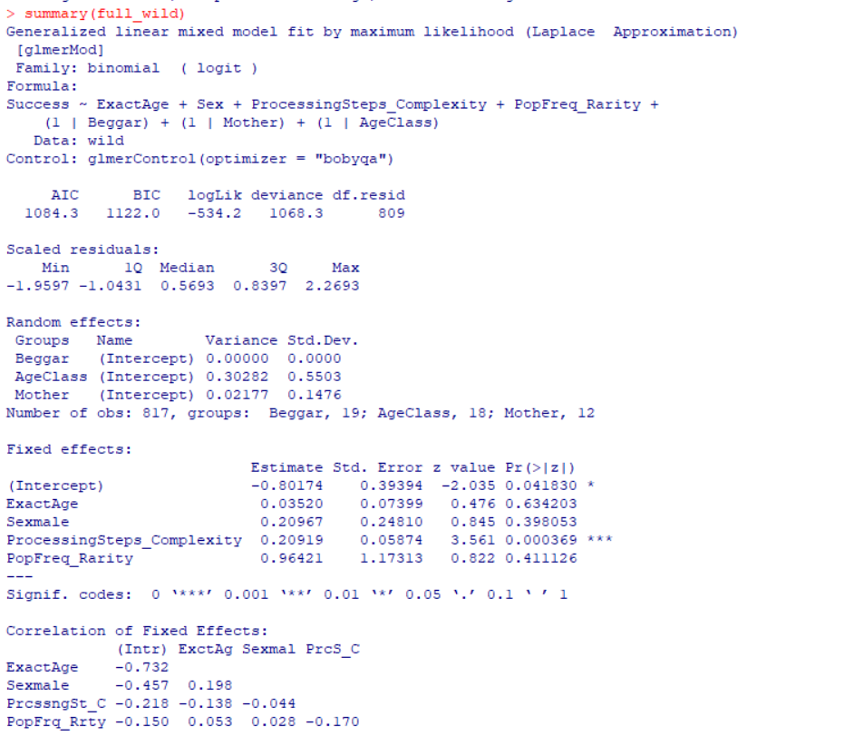

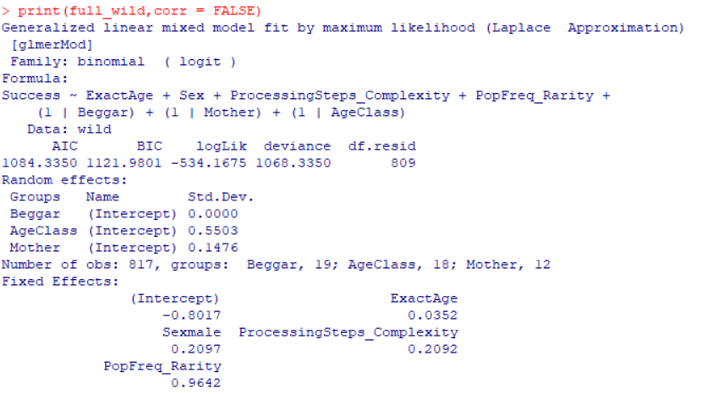

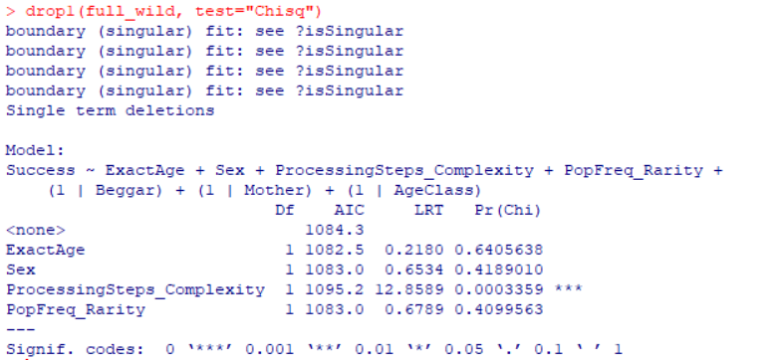

**Plots (from both raw data and model residuals [predicted probabilities])**

1. Success~ Complexity (matching results)

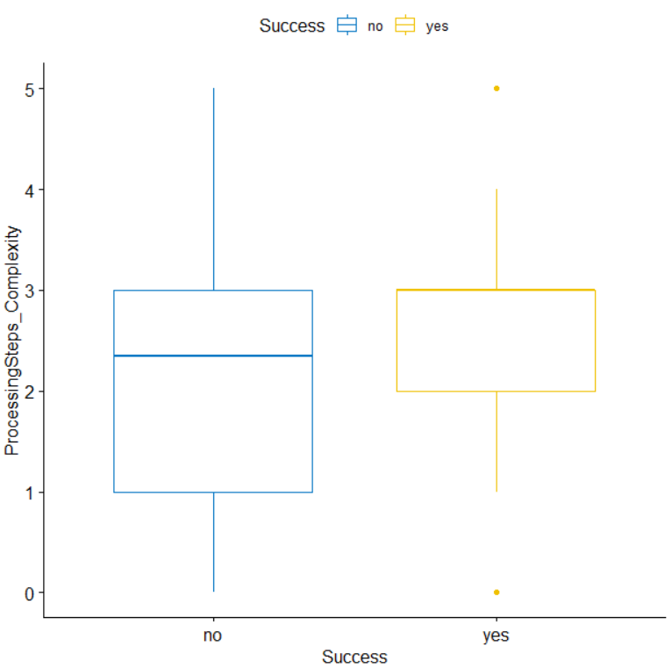

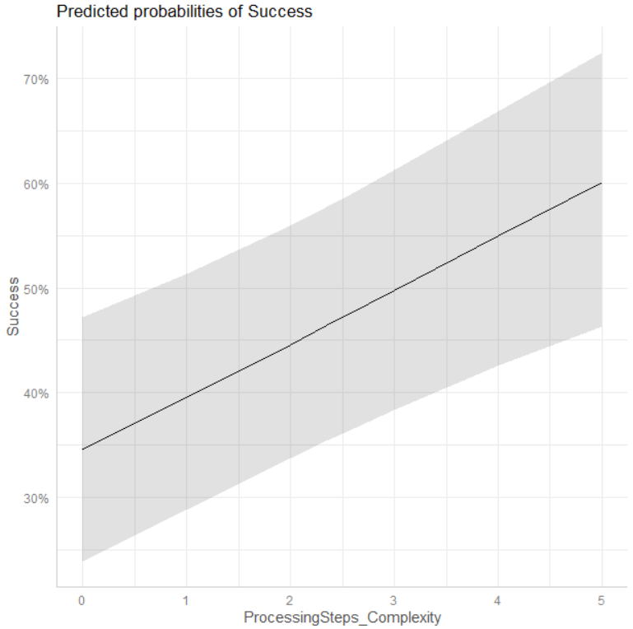

1. Success ~ Exact age (matching results)

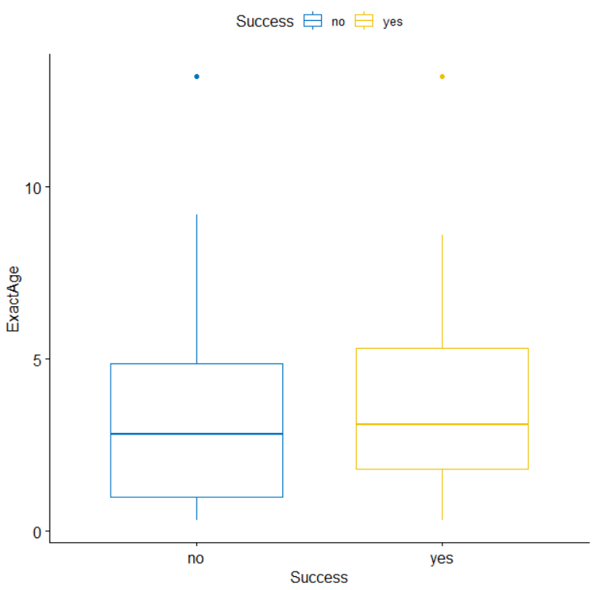

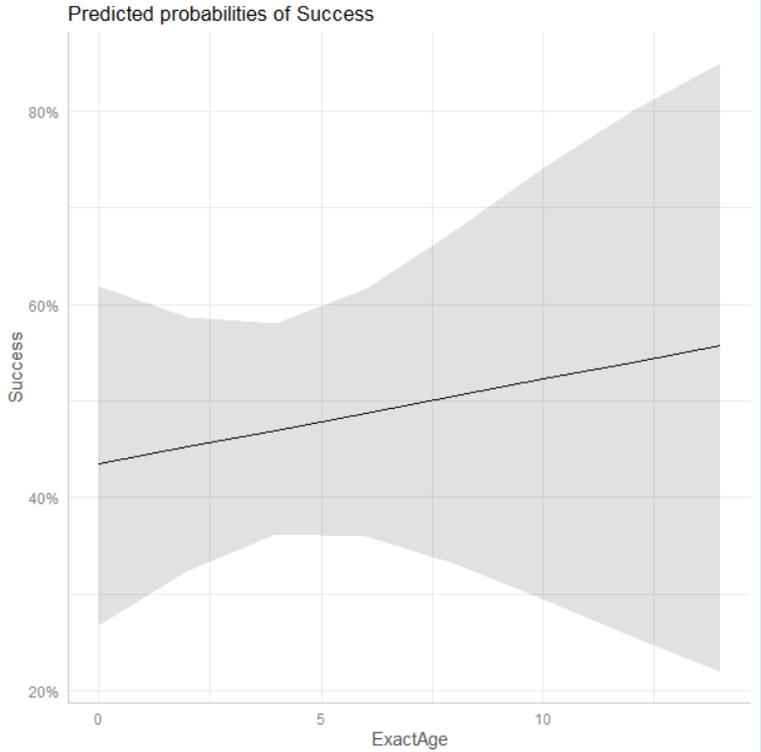

1. Success ~ Rarity (matching results)

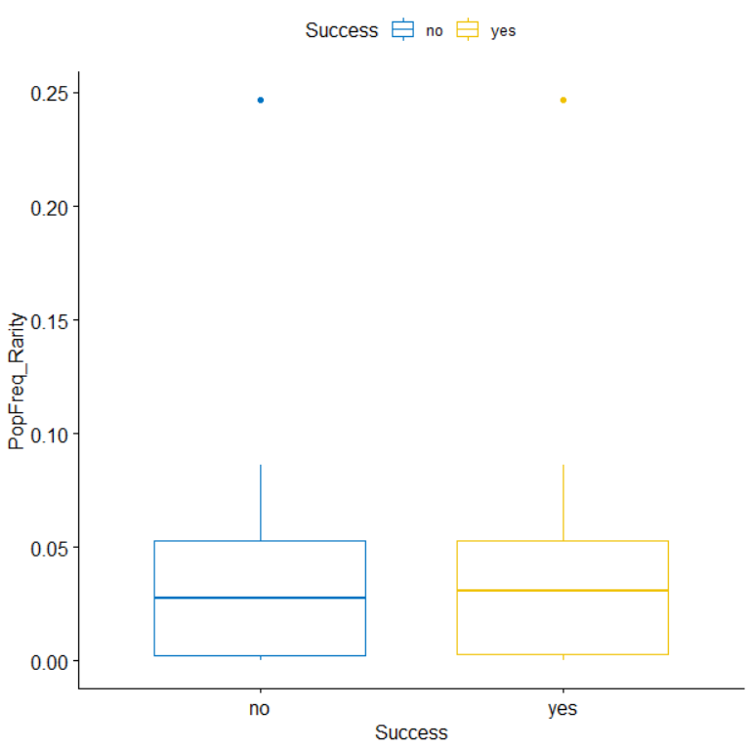

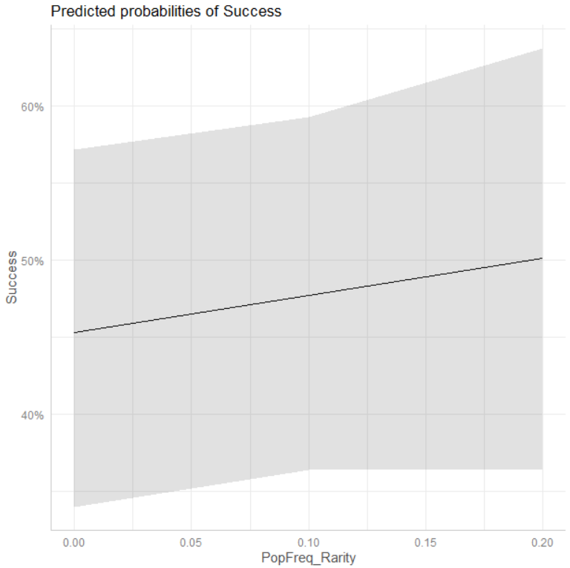

1. Success ~ Sex (matching results)

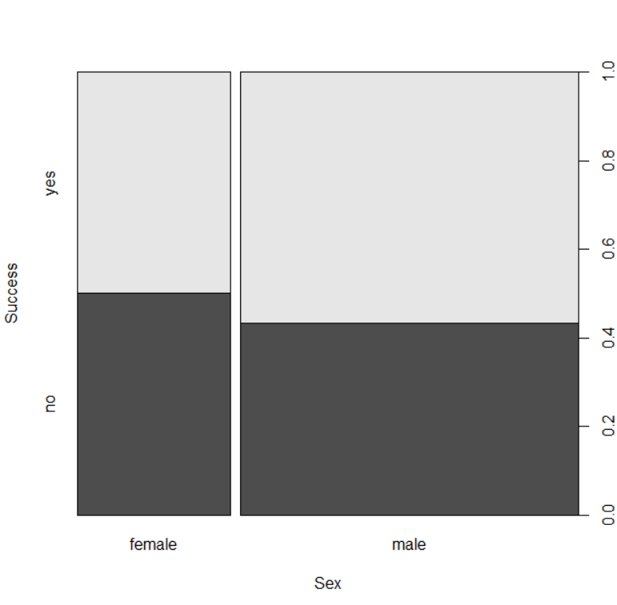

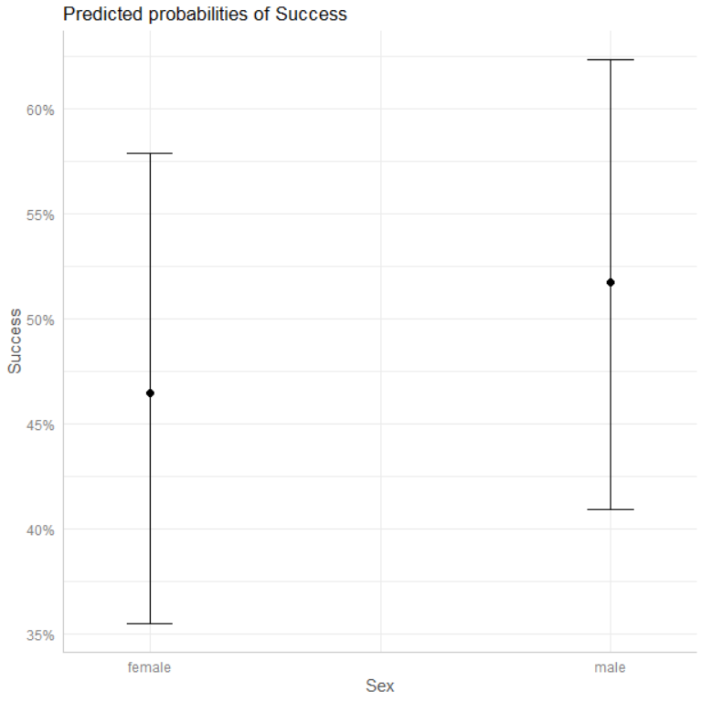

2.2. Model suggested by Miki

**Model structure**: full_wild<- glmer(Success ~ Age + Sex + ProcessingSteps_Complexity+PopFreq_Rarity+(1|Beggar)+(1|Date), data =wild, family = binomial, control = glmerControl(optimizer = "bobyqa"),nAGQ = 1)

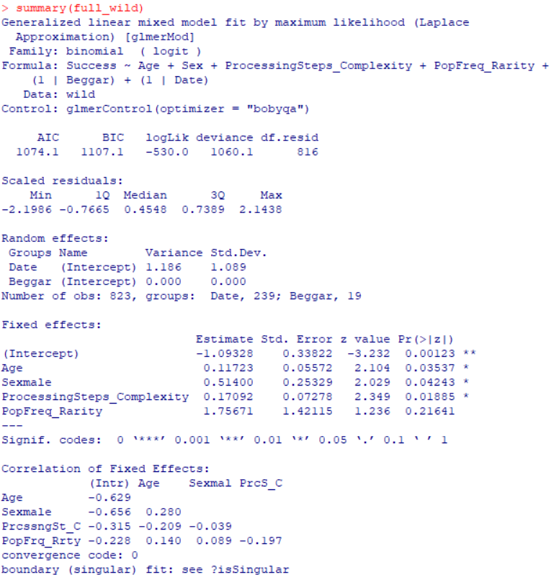

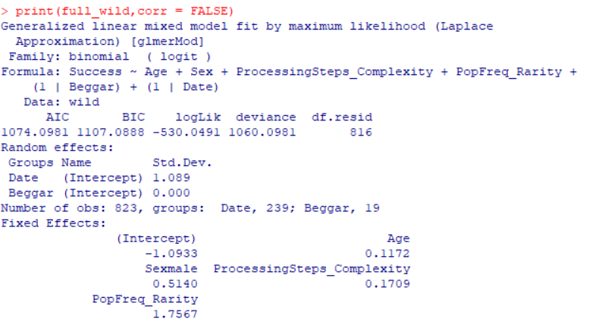**Plots (from model residuals [predicted probabilities] only)**

1. Success ~ AgeClass (similar results as the Exact age model but more significant)

1. Success ~ Complexity (similar results as the Exact age model but more significant)

1. Success ~ Sex (similar results as the Exact age model but more significant)

1. Success ~ Rarity (similar results as the Exact age model with **no** significance)

3. Effects on Begging Rate & Frequency **(based on the wild data set only)**

3.1. Model suggested by Caroline: Begging rate

**Begging rate = No. begging events on the food item X during a half-yearly time window/ No. feeding bouts of the mother on the same food item during the same time window (begging opportunities for the subject infant)**

**Model structure**: full_begrate = lmer(BeggingRate ~ Age + Sex +ProcessingSteps_Complexity+ PopFreq_Rarity +(1|Mother/Beggar), data = con, REML=F)

*I'm not trying to get inferences from the random intercepts, the singular fit issue can be therefore ignored (Roger Mundry, 2020).*

**Plots (from the raw data & model residuals [predicted probabilities])**

1. Begging rate ~ AgeClass (matching results)

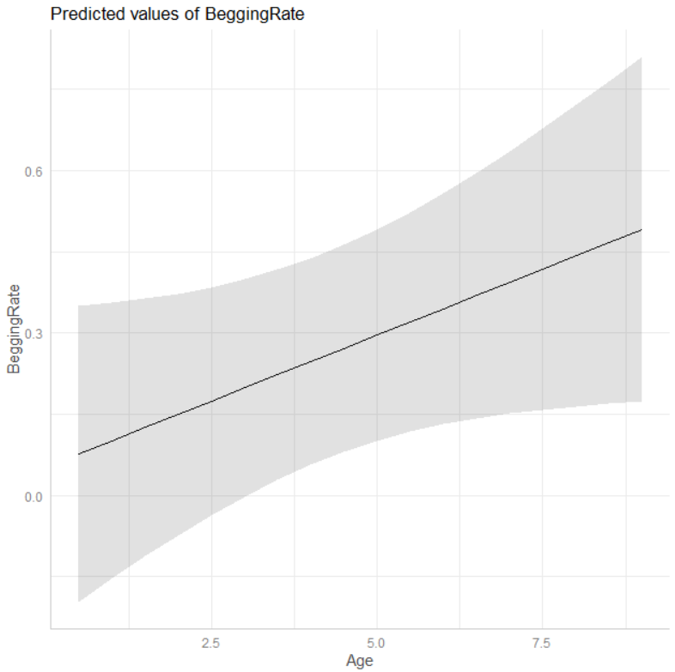

1. Begging rate ~ Sex (matching results)

1. Begging rate ~ Complexity (matching results)

1. Begging rate ~ Rarity (matching results)

3.2. Model suggested by Caroline: Begging frequency

**Model structure**: full_begfreq = lmer(BeggingFreq ~ Age + Sex +(1|Mother/Focal), data = half, REML=F)

**Begging frequency= No. begging events on the food item X during a half-yearly time window (called ‘AgeClass’) / Sum of follow hours during the same time window**

*it’s important to note that the follow hours haven’t been finalized yet because regarding the data collection, all follows that have been looked at should be included regardless of if there was any begging event noted in them. So, we are still in the process of including and excluding some follow hours.

1. Model distribution
2. Begging frequency ~ Age Class
3. Begging frequency ~ Sex

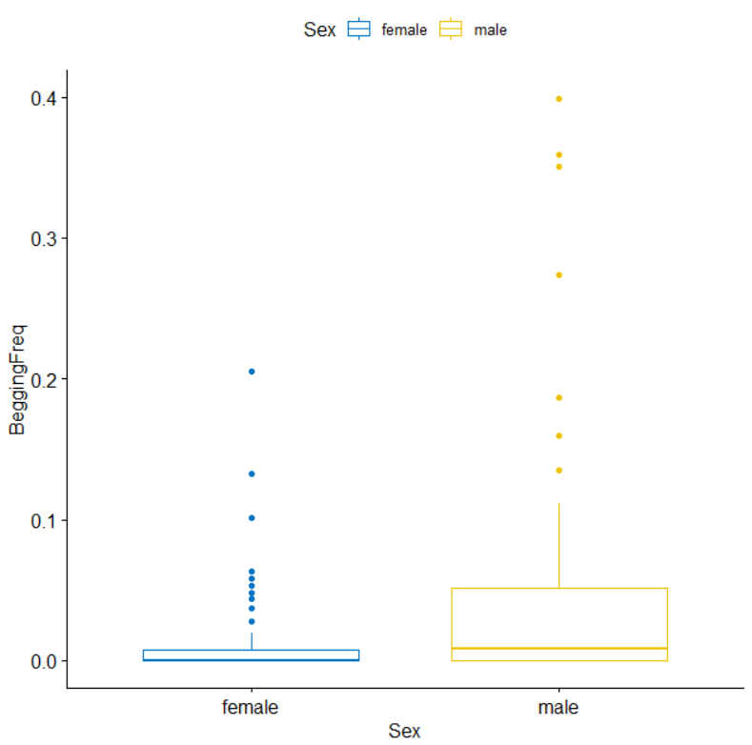

1. Begging frequency ~ number of begging events

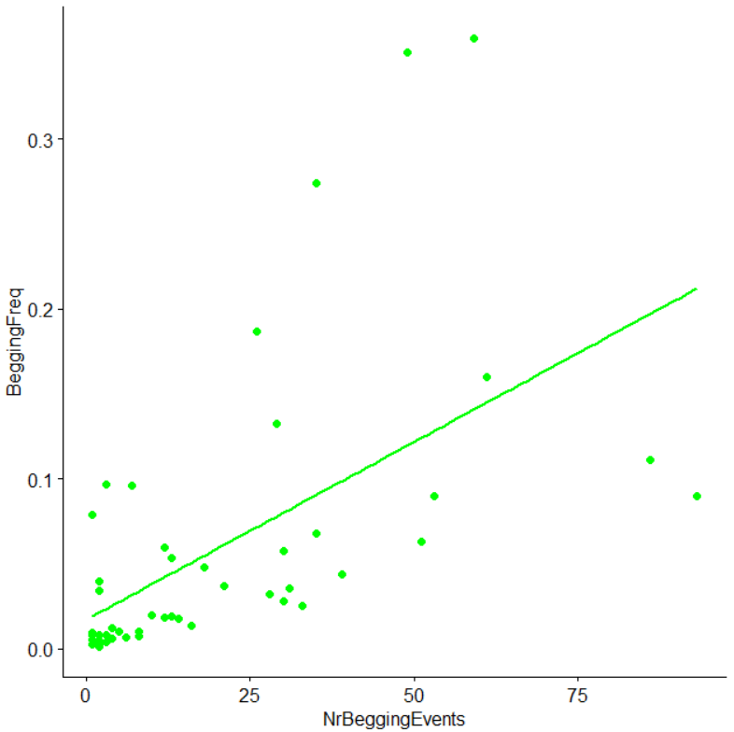

3.3. Correlational tests suggested by Miki

**Plots**

a. Begging frequency and age class (significantly correlated as the model above suggests)

b. Begging frequency and gender (significantly correlated but not significant in the model above)

4. Comparison of wild and zoo data **(four models based on both wild and zoo data sets)**

4.1. Model a: full_conwz = lm(BeggingFreq~ Site + AgeClass, data = conzoowild)

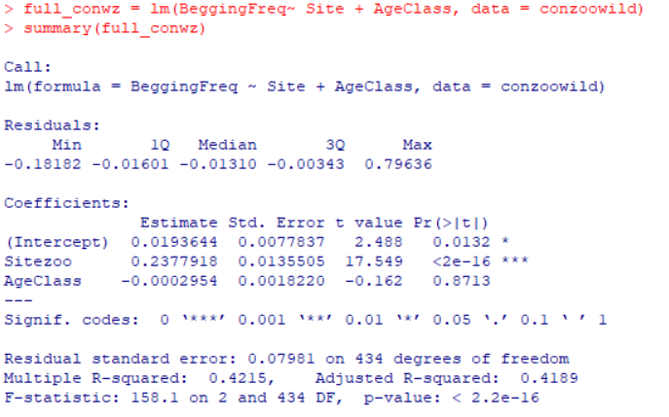

**Plots**

1. Distribution of the model residuals (looking good)
2. Begging frequency ~ Site (matching results from both raw and predicted values)
3. Begging frequency ~ Age Class (transformed to factor)

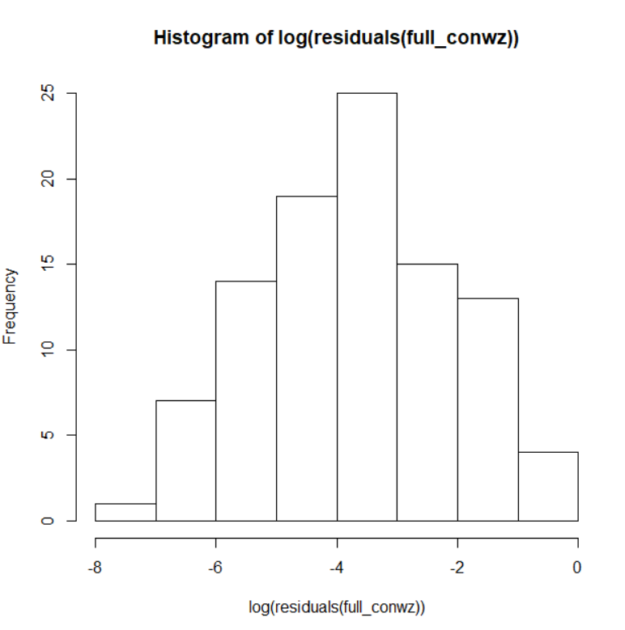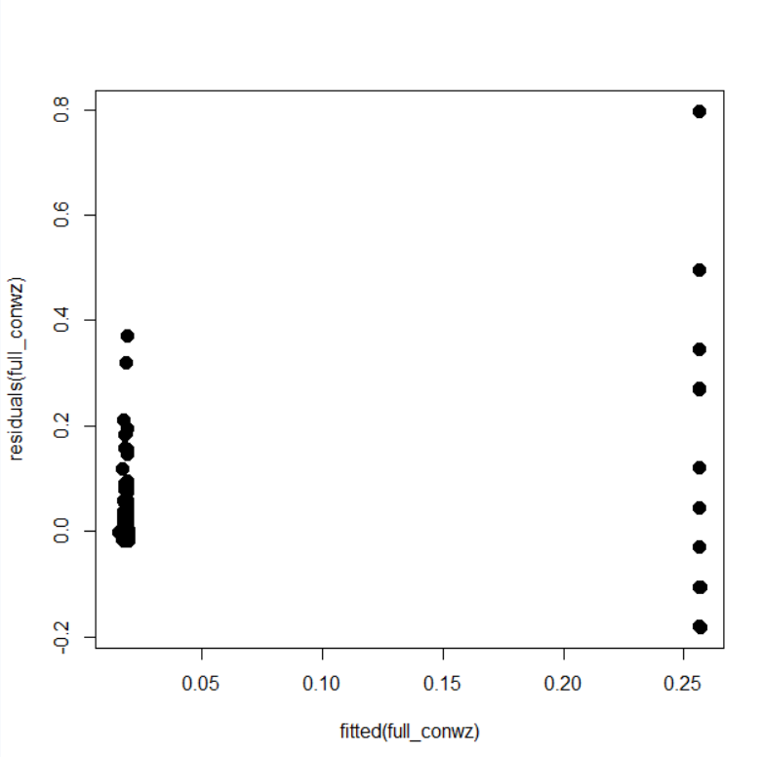

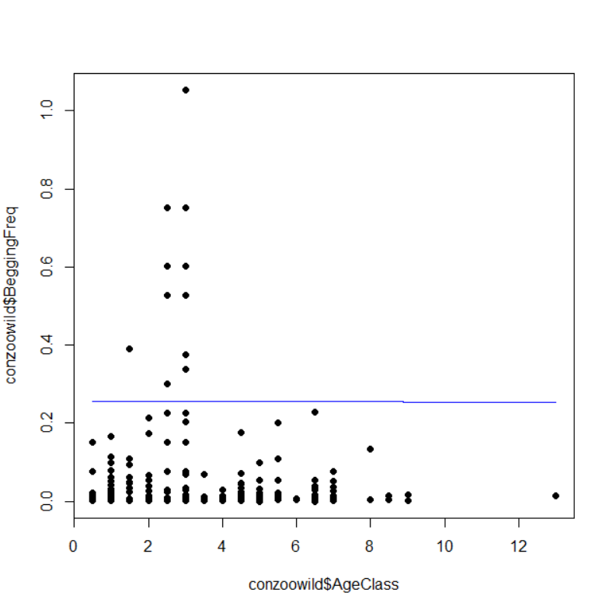

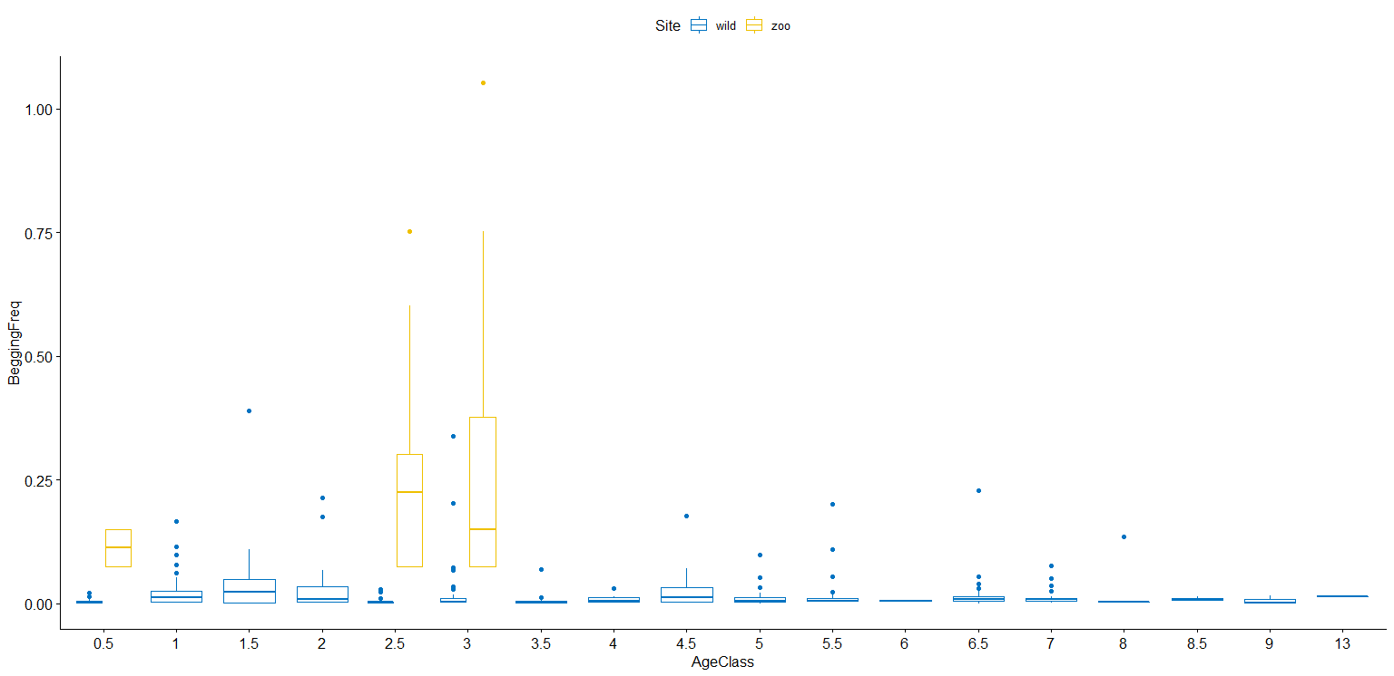

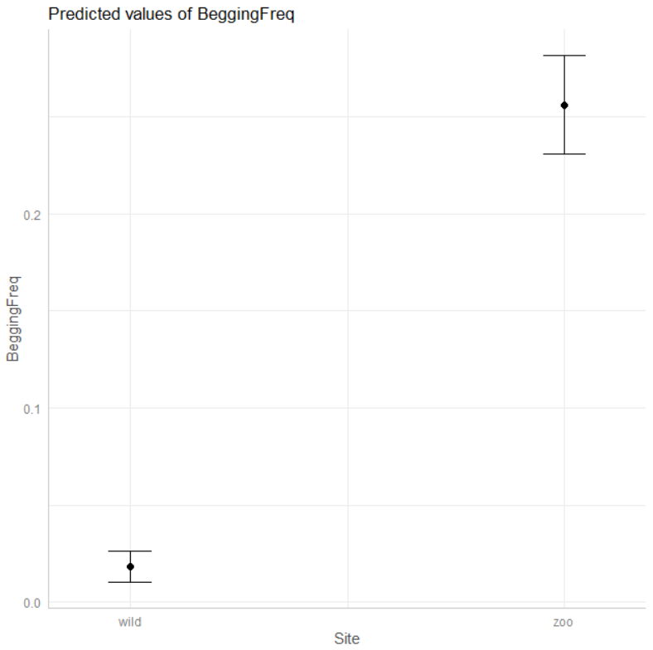

4.2. Model b: Success ~ Site + ExactAge (Binomial,data:full_ana)

**Model structure in R**:

full_gen<- glm(Success ~ Site + ExactAge ,data = full_ana, family = binomial)

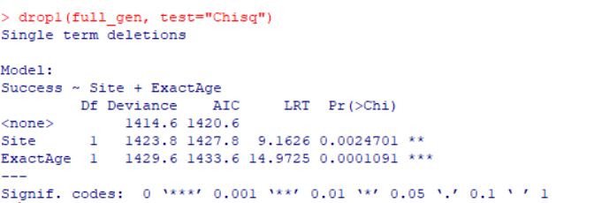

**Plots**

1. Distribution of the model residuals
2. Success ~ Site (matching results)
3. Success ~ Exact Age (matching results)

4.3. Model c: Success ~ ExactAge + Sex+ Complexity+ Rarity + Desirability+ (Binomial, data:zooage)

**Model structure in R**: full_zooage<- glm(Success ~ ExactAge + Sex + ProcessingSteps_Complexity+ PopFreq_Rarity_Onetofive + Desirability_OnetoSeven,data = zooage, family = binomial) A screenshot of a cell phone

**Plots**

1. Model distribution
2. Success ~ ExactAge
3. Success ~ Sex
4. Success ~ Complexity
5. Success ~ Rarity
6. Success ~ Desirability

4.4. Model d: Begging Frequency ~ AgeClass + Sex+ Complexity + Rarity + Desirability (multiple regression, data: zoocon)

**Model structure in R**: full_zoocon = lm(BeggingFreq~AgeClass+Sex+Complexity+Rarity+Desirability, data = zoocon)

**Plots**

1. Model distribution
2. Begging Frequency ~ Age class & Sex
3. Begging Frequency ~ Complexity
4. Begging Frequency ~ Rarity
5. Begging Frequency ~ Desirability

